  Tony Thurmond |   Marshall Tuck
 | 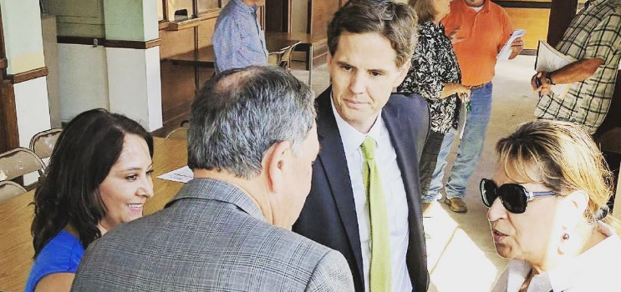
Thurmond has always kept California’s kids as his top priority when serving as a state Assembly member, school board trustee and city councilman. While on the West Contra Costa School Board, he oversaw truancy prevention programs, supported school-based mental health programs and launched a program to teach entrepreneurship skills to disadvantaged students. Thurmond was inspired to become a social worker to help at-risk kids and is now running for Superintendent to fight for all students and educators.  Thurmond brings millions to students. He passed legislation to provide millions of dollars to school districts to keep kids in school and out of the criminal justice system, fought for money to make sure all California youth in foster care can go to college, and increased funding for early education programs.  Thurmond fights for teachers’ rights and is committed to ending the teacher shortage. He believes in supporting educators instead of blaming them – giving them the compensation, resources and tools necessary for them to succeed. “If we make these investments, young people will dream about becoming teachers in communities that are historically underserved and perhaps even return to their own communities one day to teach and become role models.”  Thurmond supports transparency and accountability for all public schools, including privately-run charter schools. With more than 1,200 charter schools operating in California, he does not believe we should increase the number of charters in the state. He believes charters should only be authorized by locally elected school boards. | Tuck has a record of letting down the students that need support, not punishment. As former chief of the failed Partnership for Los Angeles Schools (PLAS), Tuck received a vote of no confidence from the teachers in several PLAS schools. He also eliminated Ethnic Studies and Dual Immersion programs from the communities who needed them most.  Tuck is bankrolled by billionaires. Wall Street billionaires are committed to spending $15 million to elect Tuck because he supports a corporate takeover of public schools that would allow out‐of‐state for‐profit companies to run California public schools with taxpayer money. He has received money from the same people who support Secretary of Education Betsy DeVos.  Tuck shares Betsy DeVos’ destructive agenda. He supports evaluating teachers based on test scores, wants to eliminate educator due process rights and supports extending probationary period to five years or more. Electing Tuck is the top priority of groups whose mission is to scapegoat teachers, weaken their rights, undermine their secure retirement, and even eliminate teachers’ unions.  Tuck support the expansion of unregulated charter schools at the expense of our neighborhood public schools. He’s beholden to the corporate billionaires funding his campaign whose agenda is to divert taxpayer dollars from California’s neighborhood public schools to fund privately-managed charter schools, without accountability or transparency to parents and taxpayers.

